**Chapter 3 – Remove the clutter**

Talks about removing everything that is not adding informative value (excessive cognitive load).

People like computers have a finite retention of the message, and is better to send a short, sweet and understandable message instead of cramping a PowerPoint slide with a lot of information that the audience is trying hard to decipher and gets just limited information from it before getting distracted with something else.

Clutter or excessive cognitive load cause communication to feel more complicated that it really is, and the audience can lose interest in trying to receive the message.

Gestalt Principles of Visual Perception states six principles: Proximity, Similarity, Enclosure, Closure, Continuity and Connection.

Chapter also teaches how to “Declutter” (In a Chart):

Remove the chart borders, gridlines, data markers, clean up axis labels, label data directly and leverage consistent color.

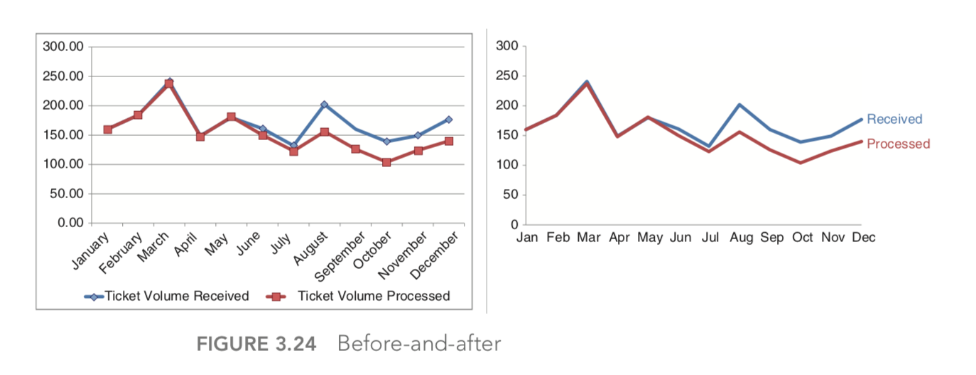

**Chapter 4 – Focus your audience attention.**

This chapter is a continuation of previous chapter. After removing the clutter, is important to look at what remains and consider how we want our audience to interact with our visual communications.

Within the brain, there are three types of memory that are important to understand as we design visual communications: iconic memory, short‐term memory, and long‐term memory. Each plays an important and distinct role.

Iconic memory is super-fast. It happens without you consciously realizing it and is piqued when we look at the world around us.

Short‐term memory has limitations. Specifically, people can keep about four chunks of visual information in their short‐term memory at a given time.

When something leaves short‐term memory, it either goes into oblivion and is likely lost forever or is passed into long‐term memory. Long‐term memory is built up over a lifetime and is vitally important for pattern recognition and general cognitive processing.

There are aspects of long‐term memory that we want to make use of when it comes to having our message stick with our audience.

**Preattentive attributes:**

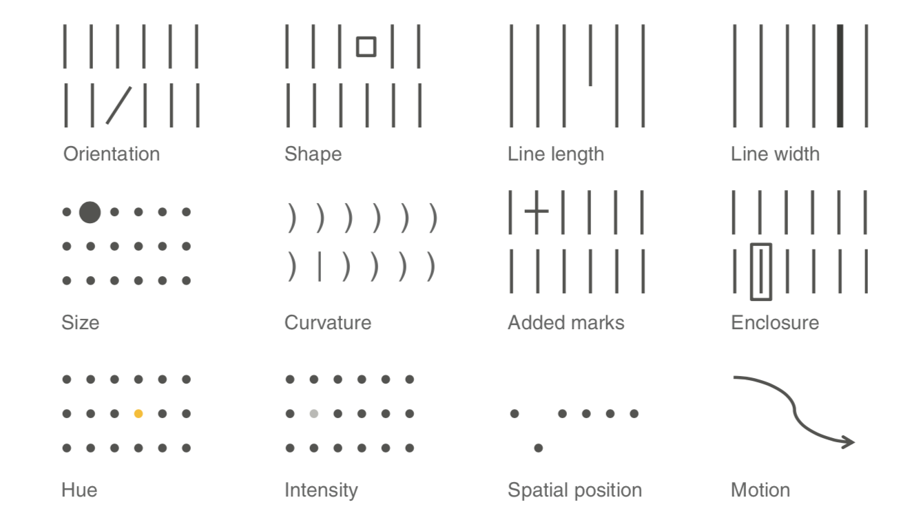

Your eye is drawn to the one element within each group that is different from the rest: you don’t have to look for it. That’s because our brains are hardwired to quickly pick up differences we see in our environment.

Beyond drawing our audience’s attention to where we want them to focus it, we can employ preattentive attributes to create visual hierarchy in our communications.

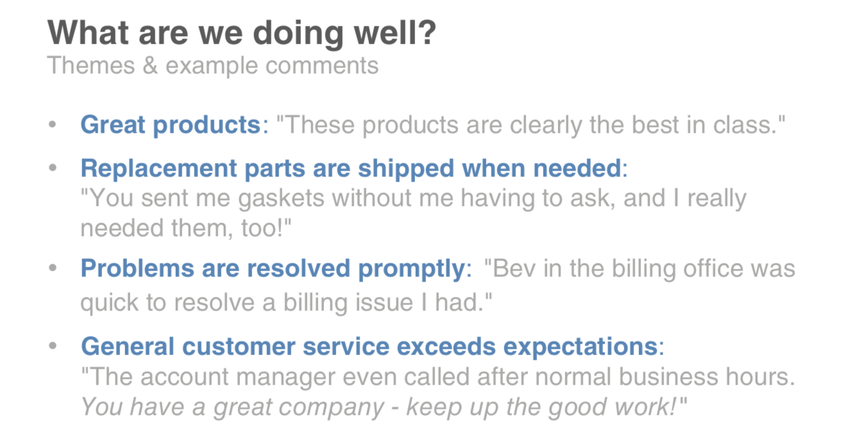

**Chapter 5 – Think like a designer**

Designers know the fundamentals of good design but also how to trust their eye.

Affordances: In the field of design, experts speak of objects having “affordances.” These are aspects inherent to the design that make it obvious how the product is to be used.

Highlight the important stuff: Bold, Color, Size

Eliminate distractions: Airman’s Odyssey, Antoine de Saint‐Exupery famously said, “You know you’ve achieved perfection, not when you have nothing more to add, but when you have nothing to take away”.

Accessibility: Applied to data visualization, I think of it as design that is usable by people of widely varying technical skills. You might be an engineer, but it shouldn’t take someone with an engineering degree to understand your graph.

Don’t overcomplicate, make it legible, keep it clean, use straightforward language and remove unnecessary complexity.

Aesthetics: Studies have shown that more aesthetic designs are not only perceived as easier to use, but also more readily accepted and used over time, promote creative thinking and problem solving, and foster positive relationships, making people more tolerant of problems with designs.

In data visualization and communicating with data in general spending time to make our designs aesthetically pleasing can mean our audience will have more patience with our visuals, increasing our chance of success for getting our message across.

By understanding and employing some traditional design concepts, we set ourselves up for success in communicating with data. Offer your audience visual affordances as cues for how to interact with your communication: highlight the important stuff, eliminate distractions, and create a visual hierarchy of information. Make your designs accessible by not overcomplicating and by leveraging text to label and explain.

**Chapter 6 – dissecting model visuals**

This chapter talks about the model visual.

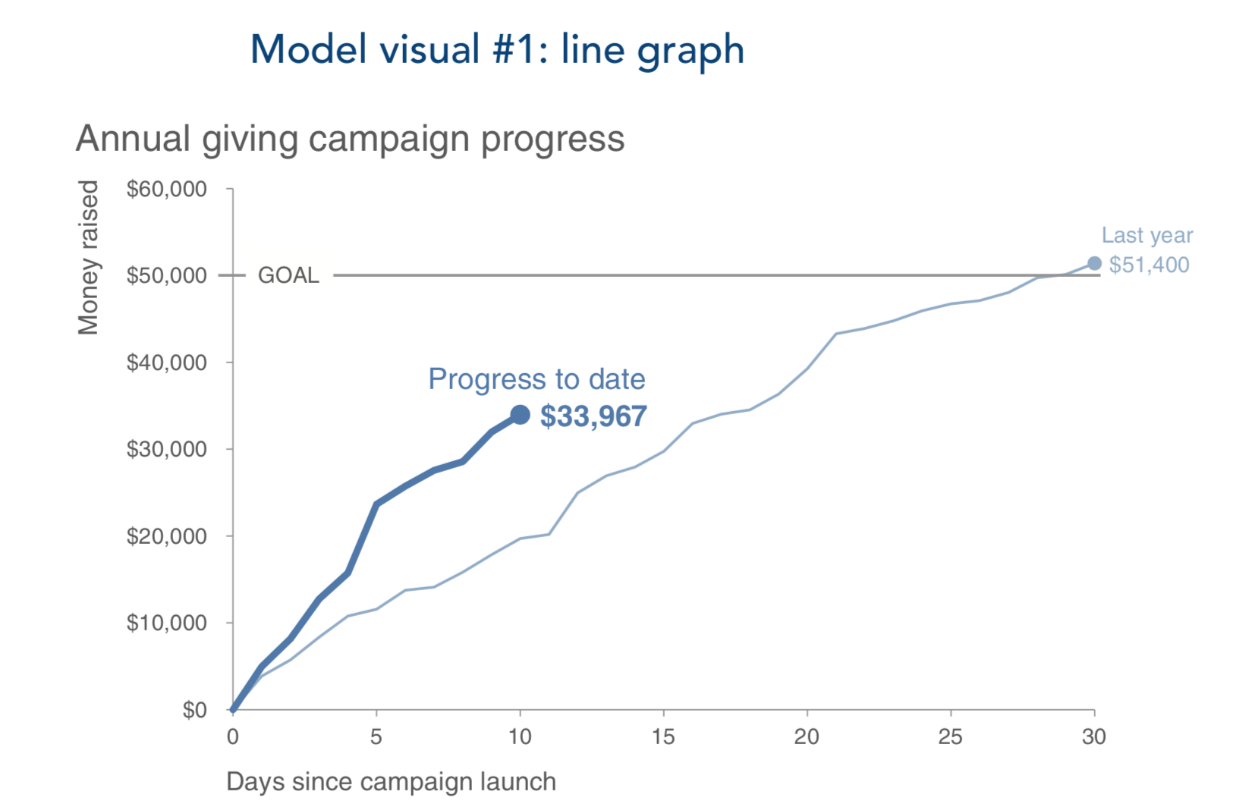

Everything is titled and labeled, so there’s no question about what we are looking at.

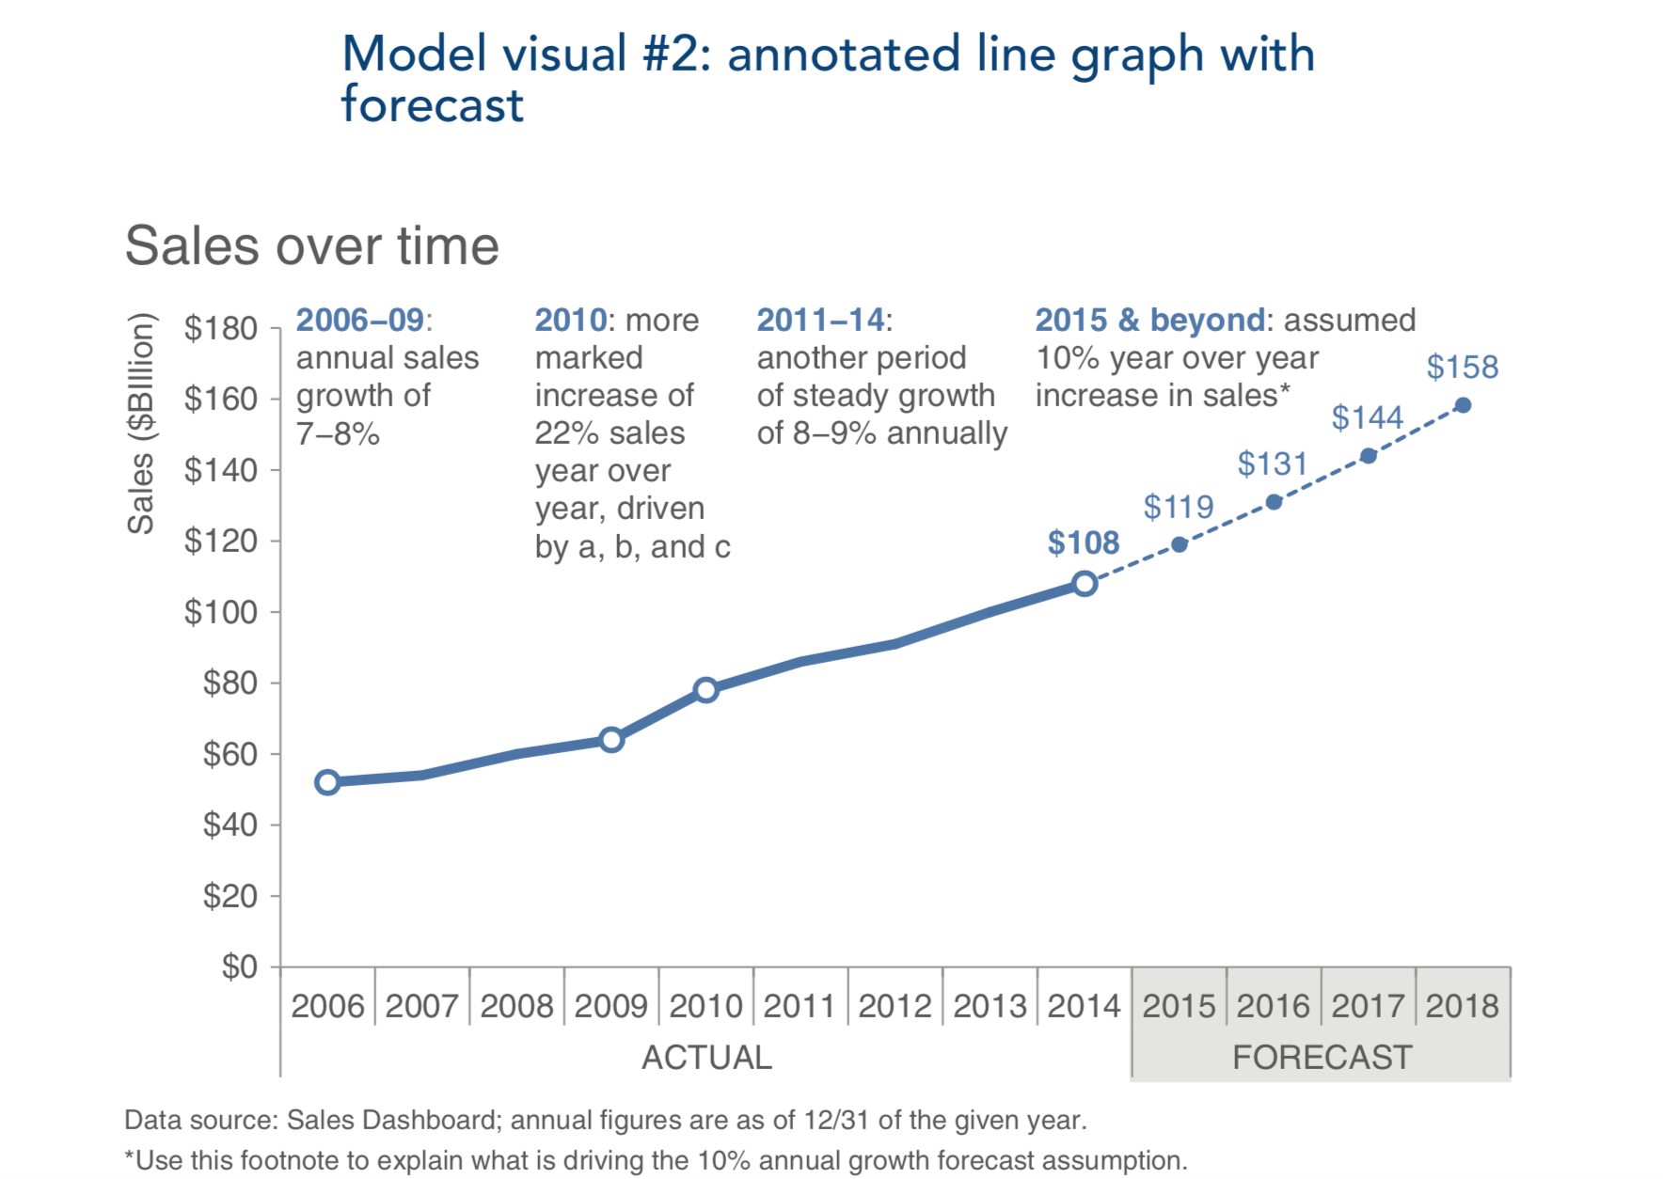

When we consider the visual hierarchy of elements, my eye goes first to the graph title at the top left

We can learn by examining effective visual displays and considering the design choices that were made to create them.